The University of Alabama
College of Education
Syllabus Template Requirements

- Course Title; department prefix; section number; term; credit information
- Instructor’s name and all contact information
- Mission of the College of Education
Our mission at the Capstone College of Education is to be a leader in Alabama and across the nation in teaching, scholarship, advocacy, and service by developing professionals with pedagogic and disciplinary expertise who advance the intellectual and social conditions of all learners in a globalized society.
- Conceptual Framework Summary
The vision of the College of Education (COE) at The University of Alabama is to develop effective, ethical, and reflective professionals who advance the theme of the COE: Unite, Act, and Lead (UA Leads). By engaging in theoretically informed and intellectually advanced effective practice our graduates will

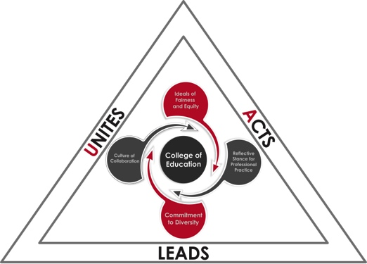
UNITE with the larger community to collaboratively nurture cultural competence, empathy, and a vision of equity and justice for all learners;
ACT to develop the full potential of all learners to be excellent professionals in their fields; and
LEAD through continuous research-based critical inquiry of policy and reflective practice to enable transformative change in our diverse local and global communities.

- Dispositions
We strive to create programs that emphasize Fairness and Equity, Reflective Stance for Professional Practice, a Commitment to Diversity, and a Culture of Collaboration.
- Prerequisites
- Course Description
- Required Texts
- Course Objectives
- Student Learning Outcomes
- Other Course Materials
- Outline of Topics
- Exams and Assignments
- Grading Policy
- Policy on Missed Exams and Coursework
- Attendance Policy
- Statement on Academic Misconduct
- Students are expected to be familiar with and adhere to the official Code of Academic Conduct provided in the Online Catalog (https://catalog.ua.edu).
- “All students in attendance at The University of Alabama are expected to be honorable and observe standards of conduct appropriate to a community of scholars. Academic misconduct by students includes all acts of dishonesty in any academically related matter and any knowing or intentional help or attempt to help, or conspiracy to help, another student commit an act of academic dishonesty. Academic dishonesty includes, but is not limited to, the following acts, when performed in any type of academic or academically related matter, exercise or activity:
  - Cheating: Using or attempting to use unauthorized materials, information, study aids or computer-related information.
  - Plagiarism: Representing the words, data, works, ideas, computer programs or output, or anything not generated in an authorized fashion, as one's own.
  - Fabrication: Presenting as genuine, any invented or falsified citation or material.
  - Misrepresentation: Falsifying, altering or misstating the contents of documents or other materials related to academic matters, including schedules, prerequisites and transcripts.”
- Statement on Disability Accommodations
- Contact the Office of Disability Services (ODS) as detailed in the Online Catalog.
- The Office of Disability Services (ODS) is the central contact point for UA students with disabilities. The goal of ODS is to ensure that University programs and services are accessible to qualified students with disabilities. For student who may require their services more information is available at http://ods.ua.edu. ODS is located at 1000 Houser Hall and their phone number is 348-4285 (voice) or 348-3081 (TTY).
- Severe Weather Protocol
- Please see the latest Severe Weather Guidelines in the Online Catalog. The link for the Severe Weather Guidelines is https://ready.ua.edu/severe-weather-guidelines/
- UAct Statement
The UAct website provides an overview of The University's expectations regarding respect and civility. The website link is https://www.ua.edu/campuslife/uact/
- Statement on Religious Observances
- The University of Alabama respects the religious diversity of our academic community and recognizes the important of religious hold days and observances in the lives of our community members. For more information, please go to http://provost.ua.edu/religious-observances.html
- Statement on Academic Work Duplication
- Any submission of academic work designed to meet the requirements of a particular credit-bearing course is assumed to be work completed for that course and only that course; the same material submission, or material that is substantially similar, may not be used to meet the requirements of another course. Any violation of this rule may results in
a referral to the Associate Dean for Student Services and Certification for disciplinary action.
- Elasticity Statement.
- Students will be given timely notice of any changes in the syllabus. Any special considerations (e.g., opportunities to earn extra credit) offered to a student shall be available to all students in the class. Adapted from The University of Alabama Faculty Handbook and Office of Academic Affairs

- Pregnant Student Accommodations
  - Title IX protects against discrimination related to pregnancy or parental status. If you are pregnant and will need accommodations for this class, please go to https://www.ua.edu/campuslife/uact/information/pregnancy

Directions to submit syllabi through UA’s Syllabus Management System
1. Log into Mybama.ua.edu with your Mybama ID and Mybama password.
2. Go to http://oira.ua.edu/d/content/secure-site-login and select
Online Syllabus Management at the bottom.
3. Select Manage-create and edit syllabi, and go to Manage My Classes.
4. Click Go to My Classes.
5. You will see Spring 2018 classes you teach at the top of the next page.
Please review your class(es); you MUST submit and publish course syllabi for courses designated as REQUIRED. If this is a new course click create and proceed. You will be provided with boxes to copy and paste your content; click edit on the right side and then you can copy the text requested from your syllabus and insert it into the template.
6. Once you have completed the sections, you will select Publish Syllabus.

Please make sure the syllabus has been published by January 16, 2018 or it will be listed as incomplete. For additional information, go to: http://syllabi.ua.edu/osm/help/frequently-asked- questions

